**1.Describes Operating System with it features.**

An operating system is system software that manages computer hardware and software resources and provides services for computer programs.

**Features :**

1. **Resource Management:**- Manages hardware components like CPU, memory, storage, and I/O devices efficiently.
2. **User Interface:**- Provides a graphical or command-line interface for user interaction with the system.
3. **Multitasking and Process Management:**- Allows multiple programs to run at the same time and manages their execution.

**2. Describe the advantages and disadvantages of Operating System**.

**Advantages:**

1. **Efficient Resource Management:** Ensures optimal use of hardware like CPU, memory, and devices.
2. **User-Friendly Interface:** Simplifies interaction with the computer through GUIs or CLIs.
3. **Multitasking:** Allows multiple applications to run simultaneously.

**Disadvantages:**

1. **Cost:** Some OS like Windows or macOS can be expensive.
2. **Complexity:** Advanced features can be difficult for beginners to understand.
3. **Security Risks:** Popular OS are common targets for malware and cyber-attacks.

**3. Describes Process control block with it features.**

A Process Control Block is a data structure used by the operating system to store all the information about a process.

**Features of PCB:**

1. **Process ID (PID):** Unique identifier for each process.
2. **Process State:** Current status of the process (e.g., running, waiting, ready).
3. **CPU Registers and Program Counter:** Stores the current values when a process is switched.

**4.Describe the importance of Kernel in Operating System.**

**1.** **Core Component:**- The kernel is the central part of the operating system that directly interacts with the hardware. It acts as a bridge between applications and the physical components of a computer.

**2**. **Resource Management:**- It efficiently manages system resources like CPU, memory, and I/O devices by allocating them to processes as needed.

**3**. **Process and Task Management:**- The kernel handles process scheduling, multitasking, and context switching, ensuring smooth execution of multiple tasks.

**4.** **Security and Protection:**- It provides secure access to system resources, ensures process isolation, and enforces permissions, protecting the system from unauthorized access.

**5.Describe batch processing with an example.**

Batch processing is a method of executing a series of non-interactive tasks or jobs on a computer without manual intervention. Jobs are collected in batches and processed together, usually at a scheduled time.

**Features:**

* No user interaction during execution
* Efficient for large volumes of data
* Often used for repetitive tasks

**Example:-** In a bank, daily transaction data from ATMs is collected and processed overnight in batches to update all customer account balances. This is done automatically without user input during processing.

**6. Describe benefits of a multiprocessor system.**

**1. Increased Performance:**- Multiple processors can execute different tasks simultaneously, improving the overall speed and efficiency of the system.

**2. Enhanced Reliability:**- If one processor fails, others can take over its tasks, increasing system reliability and fault tolerance.

**3. Better Resource Utilization:**- Workloads can be evenly distributed across processors, ensuring optimal use of system resources.

**4. Support for Multitasking:**- Multiprocessor systems handle multiple processes or users more efficiently, making them ideal for servers and high-performance applications.

**7.** **Describe are the advantages and disadvantages of Multithreaded Programming.**

**Advantages :**

1. **Improved Performance:-** Threads can run concurrently, making better use of CPU resources and speeding up program execution.
2. **Resource Sharing:-** Threads within the same process share memory and resources, which makes communication between them faster and more efficient.

**Disadvantages:**

1. **Complex Debugging and Testing:**- Multithreaded programs are harder to test and debug due to issues like race conditions and deadlocks.
2. **Synchronization Overhead:-** Managing access to shared resources requires synchronization, which can reduce performance and increase complexity.

**8. Differentiate among the following types of OS by defining their essential properties: Simple batch System and Real time System.**

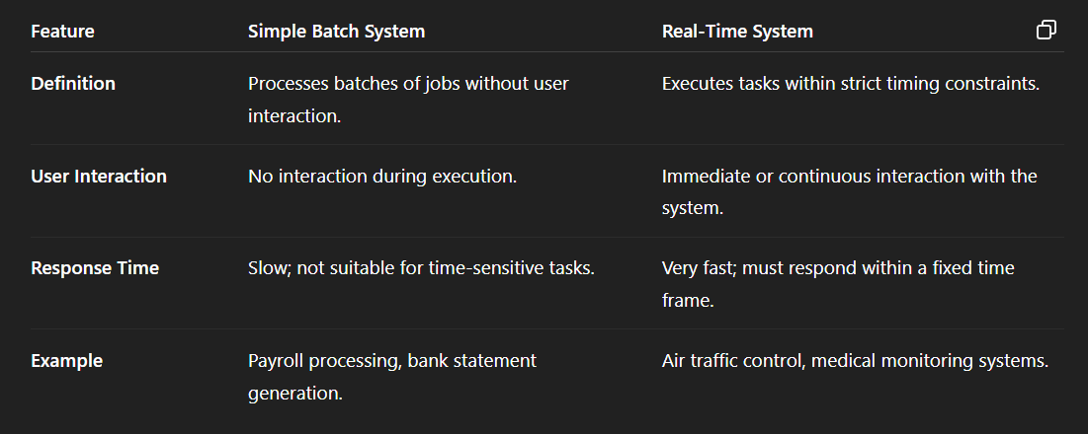

**9. Discuss the importance of Process Control Block.**

**1.** **Process Identification:** - PCB contains a unique Process ID (PID) that helps the operating system identify and manage each process separately.

**2.** **Process State Tracking:** - It stores the current state of the process (e.g., running, waiting, ready), enabling the OS to manage process scheduling effectively.

**3.** **Context Switching:**- PCB holds CPU register values and program counter so the OS can save and restore a process’s state during context switches.

**4**. **Resource Management:**- It keeps information about allocated resources (memory, files, I/O devices) ensuring proper resource allocation and process isolation.

**10. Define the two categories of CPU scheduling algorithm.**

1. **Preemptive Scheduling:** - In this category, the CPU can be taken away from a running process to assign it to another process, usually based on priority or time quantum. It allows more responsive multitasking.  
***Example:*** Round Robin, Priority Scheduling (preemptive).

**2.** **Non-Preemptive Scheduling :**- Here, once a process starts executing, it runs until it finishes or voluntarily relinquishes the CPU. No interruption by other processes occurs during execution.  
***Example:*** First-Come, First-Served (FCFS), Shortest Job Next (SJN).

**11. Discuss LRU-Approximation page Replacement.**

**1.** **Definition:** - LRU (Least Recently Used) Approximation is a technique used to replace a page in memory that approximates the true LRU algorithm without requiring full tracking of all page accesses.

**2**. **How It Works:** - Since exact LRU is expensive to implement, approximation algorithms use additional bits (like reference bits) to track if a page was recently used.

**3**. **Example Method:**- The **Clock Algorithm** is a popular LRU approximation. It cycles through pages in a circular buffer and checks a reference bit; if the bit is 0, that page is replaced; if 1, it clears the bit and moves on.

**4.** **Benefit:** - This method reduces overhead and complexity while still approximating LRU behavior, improving page replacement efficiency.

**12. Describe the importance of Semaphore**.

**1**. **Process Synchronization:** - Semaphores help coordinate multiple processes or threads by controlling their access to shared resources, preventing conflicts.

**2.** **Mutual Exclusion:** - They ensure that only one process accesses a critical section (shared resource) at a time, avoiding data inconsistency.

**3.** **Deadlock Prevention:** - Proper use of semaphores can help avoid deadlocks by managing resource allocation carefully.

**4.** **Efficient Resource Sharing:**- Semaphores enable processes to wait and signal each other, making resource sharing smooth and efficient without busy-waiting.

**13. Discuss about the generation of Operating System?**

**1**. **First Generation (1940s-1950s):**  
No operating systems; computers were operated manually with machine language programs.

**2**.**Second Generation (1950s-1960s):**  
Batch operating systems introduced to automate job sequencing but had no interaction with users during processing.

**3**.**Third Generation (1960s-1980s):**  
Multiprogramming and time-sharing systems emerged, allowing multiple processes to run concurrently and user interaction.

**4**.**Fourth Generation (1980s-Present):**  
Modern OS with graphical user interfaces (GUI), real-time processing, networking, and support for multitasking and multiprocessors.

**14.Discuss about the Process Synchronization.**

**Definition:** - Process synchronization is a technique used to ensure that multiple processes or threads can operate concurrently without interfering with each other when accessing shared resources.

**Need:**- It prevents race conditions where two or more processes try to modify shared data simultaneously, leading to inconsistent or incorrect results.

**Methods:**- Common synchronization tools include semaphores, mutexes, and monitors that help coordinate process execution and access to critical sections.

**Goal:**- The main goal is to maintain data consistency, avoid deadlocks, and ensure proper sequencing of process execution.

**15. Express the advantages of layered structure over monolithic structure?**

**Modularity:**- The layered structure divides the operating system into layers, each with a specific function, making it easier to develop, understand, and maintain.

**Ease of Debugging and Testing:**- Errors can be isolated within a specific layer, simplifying troubleshooting and testing.

**Improved Security and Reliability:**- Each layer interacts only with its adjacent layers, reducing the risk of system-wide failures and improving fault isolation.

**Flexibility and Scalability:**- Enhancements or changes can be made in one layer without affecting others, making the system more adaptable to updates and expansions.

**16. Compare between macro kernel and micro kernel ?**

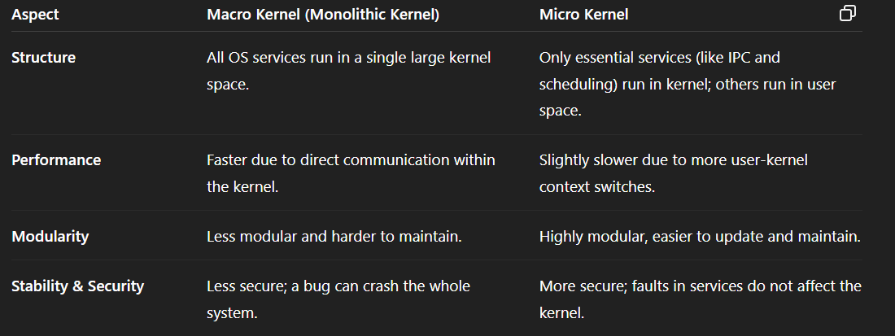

**17. Discuss about the application of User Space and Kernel Space.**

**User Space:**

* **Definition:** The memory area where user applications run.
* **Application:** It hosts programs like web browsers, word processors, and games. These applications interact with hardware through system calls without direct access.

**Purpose:** Enhances system stability and security by isolating user programs from the core system.

**Kernel Space:**

* **Definition:** The memory area where the core of the operating system (the kernel) executes.
* **Application:** Manages low-level tasks like process scheduling, memory management, device control, and system security.
* **Purpose:** Ensures controlled access to hardware and critical resources, maintaining overall system integrity.

**18.** **Explain Priority scheduling algorithm.**

1. **Definition:**- Priority Scheduling is a CPU scheduling algorithm where each process is assigned a priority. The CPU is allocated to the process with the highest priority (lower number usually indicates higher priority).
2. **Types:**
   * **Preemptive:** A running process can be interrupted if a higher-priority process arrives.
   * **Non-Preemptive:** The CPU remains with the current process until it finishes, even if a higher-priority process comes.
3. **Advantages:**
   * Important tasks get executed first.
   * Efficient for time-critical applications.
4. **Disadvantages:**
   * **Starvation:** Low-priority processes may never get executed.
   * Needs aging technique to gradually increase the priority of waiting processes.

**Example:**- If three processes have priorities 1, 3, and 2 — the scheduler runs them in order: priority 1 → priority 2 → priority 3.

**19. Explain the following process scheduling algorithm a) Priority scheduling b) Shortest job first scheduling.**

**a) Priority Scheduling :**

* **Definition:**- Each process is assigned a priority. The CPU is allocated to the process with the highest priority (usually, lower numbers indicate higher priority).
* **Types:**
  + **Preemptive*:*** A higher-priority process can interrupt a running lower-priority one.
  + **Non-Preemptive***:* CPU is given to the highest-priority process available when the CPU becomes free.

**b)shortest job first scheduling :**-

* **Definition:-** The process with the shortest burst (execution) time is scheduled first.
* **Types:**
* **Preemptive (Shortest Remaining Time First - SRTF)**: Current process may be interrupted if a new shorter job arrives.
  + **Non-Preemptive:** CPU is given to the shortest job that is ready when the CPU is free.

**20. Explain different states of a process.**

**New:-** The process is being created and is not yet ready to execute.

**Ready:-** The process is loaded into memory and waiting to be assigned to a CPU for execution.

**Running:**-The process is currently being executed by the CPU.

**Waiting (Blocked):-** The process is waiting for some event to occur (like I/O completion) before it can proceed.

**Terminated:-** The process has finished execution or has been killed, and is being removed from the system.

**21. Illustrate Deadlock with an example ?**

A **deadlock** is a situation in a multiprogramming environment where two or more processes are unable to proceed because each is waiting for the other to release a resource.

**Conditions for Deadlock:**

* Mutual Exclusion
* Hold and Wait
* No Preemption
* Circular Wait

**Example:**

* Process P1 holds Resource R1 and waits for Resource R2.
* Process P2 holds Resource R2 and waits for Resource R1.
* Both processes are waiting indefinitely, causing a deadlock.

**22. Explain the necessary conditions for achieving a Deadlock.**

**Mutual Exclusion:**- At least one resource must be held in a non-shareable mode. Only one process can use the resource at a time.

**Hold and Wait:**- A process is holding at least one resource and waiting to acquire additional resources that are currently held by other processes.

**No Preemption:**- Resources cannot be forcibly taken away from a process. A resource can only be released voluntarily by the holding process after it completes its task.

**Circular Wait:**- A circular chain of processes exists where each process holds at least one resource and is waiting for a resource held by the next process in the chain.

**23. Express your view for the differences between paging and segmentation ?**

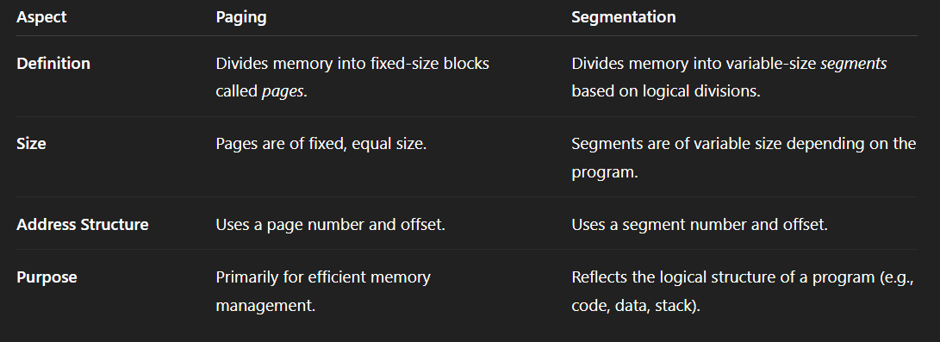

**24. Explain Semaphore with an example.**

A **semaphore** is a synchronization tool used in operating systems to manage access to shared resources by multiple processes and prevent race conditions.

**Types of Semaphores:**

* **Binary Semaphore (Mutex):** Only two values (0 and 1), used for mutual exclusion.
* **Counting Semaphore:** Allows a resource to be used by a limited number of processes.

**Working Principle:**

* **Wait (P) operation:** Decreases the semaphore value. If the value is less than zero, the process is blocked.
* **Signal (V) operation:** Increases the semaphore value. If there are blocked processes, one is unblocked.

**Example:**  
Suppose two processes need to write to a shared file. A binary semaphore is used:

Semaphore S = 1;

Process A: Process B:

wait(S); wait(S);

write to file write to file

signal(S); signal(S);

**25. Compare between Distributed system and Real time system ?**

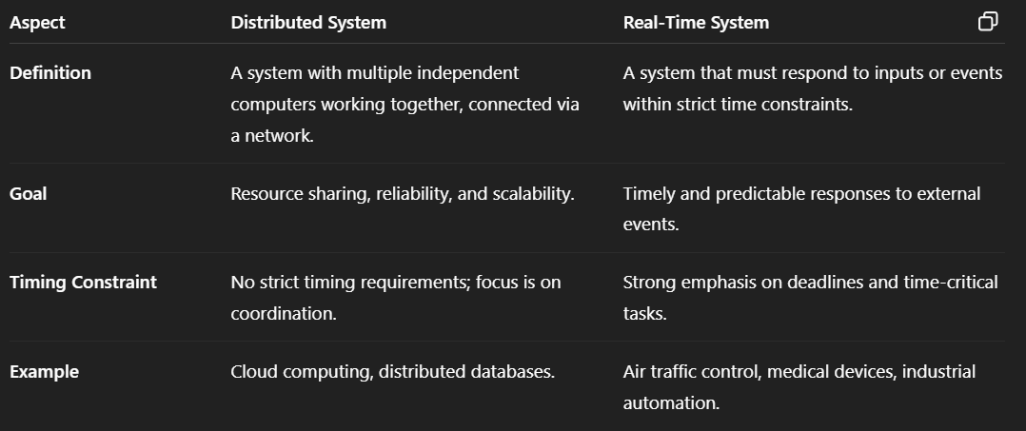

**26. Explain dinning philosopher problem & its solution.**

**Problem Statement:**

* Five philosophers sit around a circular table.
* Each philosopher alternates between thinking and eating.
* There is one fork between each pair of philosophers, and each needs **two forks** to eat (left and right).
* Problem arises when all philosophers pick up one fork at the same time and wait for the other — causing a **deadlock**.

**Challenges:**

* **Deadlock:** All pick up one fork and wait forever.
* **Starvation:** Some philosophers never get a chance to eat.

**Solution (using Semaphores):**

* Use a **semaphore** for each fork to allow only one philosopher to use it at a time.
* Use an additional **mutex** to control access to a shared counter or use a strategy to limit the number of philosophers picking forks.

**Example (Simplified Strategy):**

* Allow only 4 philosophers to try picking forks at the same time.
* This ensures at least one can eat and prevents deadlock.

semaphore forks[5] = {1, 1, 1, 1, 1};

semaphore mutex = 1;

Philosopher i:

wait(mutex);

wait(forks[i]);

wait(forks[(i+1)%5]);

signal(mutex);

// eat

signal(forks[i]);

signal(forks[(i+1)%5]);

**27. Explain Critical Section and it's effect in application point of view in OS.**

A **Critical Section** is a part of a program where shared resources (like variables, files, or devices) are accessed and modified. Only one process should execute in its critical section at a time to prevent data inconsistency.

**Need:** - Without control, multiple processes may access shared data simultaneously, causing **race conditions**, **data corruption**, or **unexpected behavior**.

**Application Impact:**

* Ensures **data integrity** in concurrent environments.
* Prevents **race conditions** in multi-threaded applications.
* Critical for applications like **banking systems**, **reservation systems**, and **file management**, where shared data must remain consistent.

**28. Explain the following terms related to IPC: a) critical region b) Race condition**

**a) Critical Region :**

* Also known as the Critical Section, it is a portion of the code where shared resources (e.g., variables, files, or memory) are accessed.
* Only one process or thread should enter the critical region at a time to prevent data inconsistency.
* **Example:** If two processes try to update a bank account balance at the same time without control, the final result could be incorrect.

**b) Race Condition :-**

* A race condition occurs when the outcome of a program depends on the sequence or timing of uncontrollable events, such as the order in which processes execute.
* It happens when multiple processes access shared data concurrently, and at least one modifies it.
* **Example:** Two threads incrementing the same counter without synchronization might lead to a lost update.

**29. Explain Peterson’s solution for achieving mutual exclusion?**

Peterson’s solution is a classic software-based algorithm used to achieve **mutual exclusion** between two processes trying to enter their **critical sections**.

**Key Concepts:**  
It uses two shared variables:

* flag[2]: Indicates if a process wants to enter the critical section (true means it does).
* turn: Indicates whose turn it is to enter the critical section.

**Properties Ensured:**

* **Mutual Exclusion:** Only one process can be in the critical section at a time.
* **Progress:** No process is indefinitely postponed.
* **Bounded Waiting:** A process will not be delayed forever by others.

**30. Explain batch system and multiprogrammed System.**

**Batch System :**

* **Definition:** A batch system processes jobs in groups (batches) without user interaction. Jobs are collected, grouped, and then executed sequentially.
* **Characteristics:**
  + No direct user interaction during execution.
  + Jobs are processed one after another automatically.
  + Efficient for executing similar types of tasks (e.g., payroll, billing).
* **Example:** Early mainframe systems where punch cards were used to submit jobs in batches.

**Multiprogrammed System (2 marks):**

* **Definition:** A multiprogrammed system allows **multiple programs** to reside in memory at the same time, with the CPU switching between them to maximize utilization.
* **Characteristics:**
  + CPU is kept busy by switching to another job when one is waiting for I/O.
  + Improves resource utilization and throughput.
  + Involves scheduling and memory management.
* **Example:** Modern operating systems that allow running multiple applications like browser, music player, and editor simultaneously.

**31. Consider the following page reference string. 1,2,3,4,5,3,4,1,6,7,8,7,8,9,7,8,9,5,4,5,4,2. Estimate total page faults occur for the following FIFO replacement algorithm, assuming four frames.**

Solve after some time .

**32 . Compare between process and thread.**

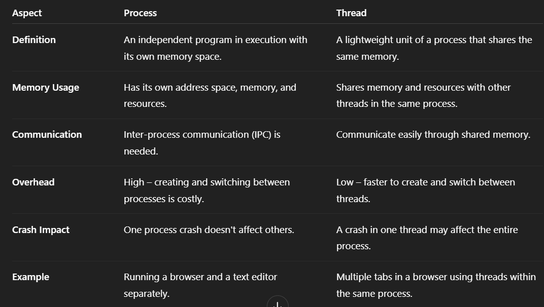

**33. Explain the advantages and disadvantages of using a linear list vs. a hash table for implementing directory structures in a file system** ?

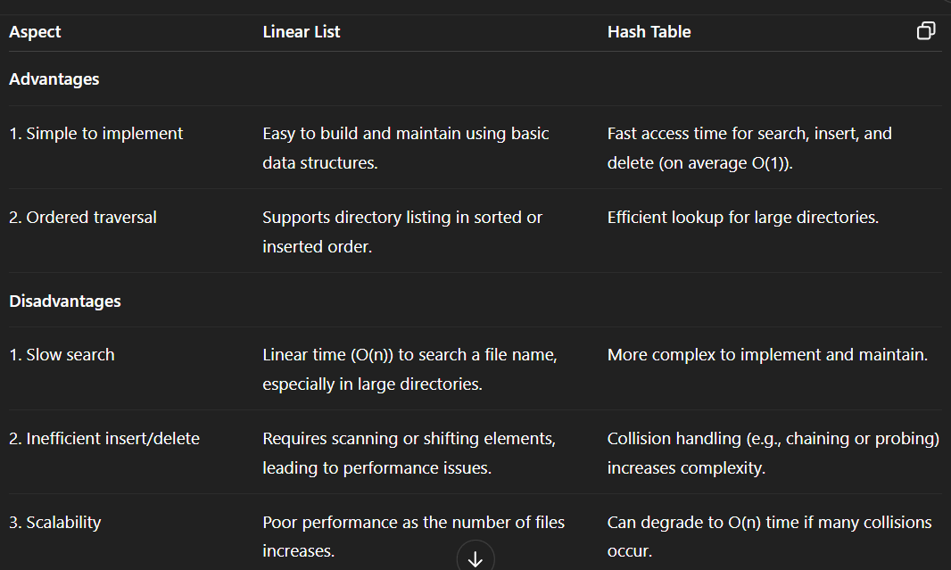

**34 . Explain the concept of a virtual file system (VFS) ?**

1. A **Virtual File System (VFS)** is an abstraction layer on top of different concrete file systems, allowing the operating system to provide a uniform interface to user programs regardless of the underlying file system types.
2. **Purpose:**
   * Enables the OS to support multiple file systems (e.g., FAT, NTFS, ext4) transparently.
   * Allows applications to access files in a consistent way without worrying about file system details.
3. **How It Works:** - VFS provides a set of common operations (like open, read, write) and data structures. When a file operation is requested, VFS routes it to the appropriate file system driver based on the file location.
4. **Benefits:**
   * **Portability:** Applications don’t need to change for different file systems.
   * **Flexibility**: New file systems can be added without modifying existing programs.

**35 . Predict about the information of an I-node file system.**

An **I-node** (Index node) is a data structure used in many file systems (like UNIX) to store metadata about a file. It contains information **about the file but not the file’s name or its actual data**.

**Key Information Stored in an I-node:**

1. **File Type and Permissions:** -Specifies whether the file is a regular file, directory, or special file, along with read, write, and execute permissions for user, group, and others.
2. **Ownership:** - Stores the user ID (UID) and group ID (GID) of the file owner.
3. **File Size:** -Total size of the file in bytes.
4. **Timestamps:**- Records important times, such as creation time, last modification time, and last access time.
5. **Link Count:** - Number of directory entries (links) pointing to this I-node.
6. **Pointers to Data Blocks:** - Addresses or pointers to the actual data blocks on disk where the file’s contents are stored (including direct, indirect, double indirect pointers).

**36. Compare and contrast the following disk scheduling algorithms: FCFS, SSTF.**

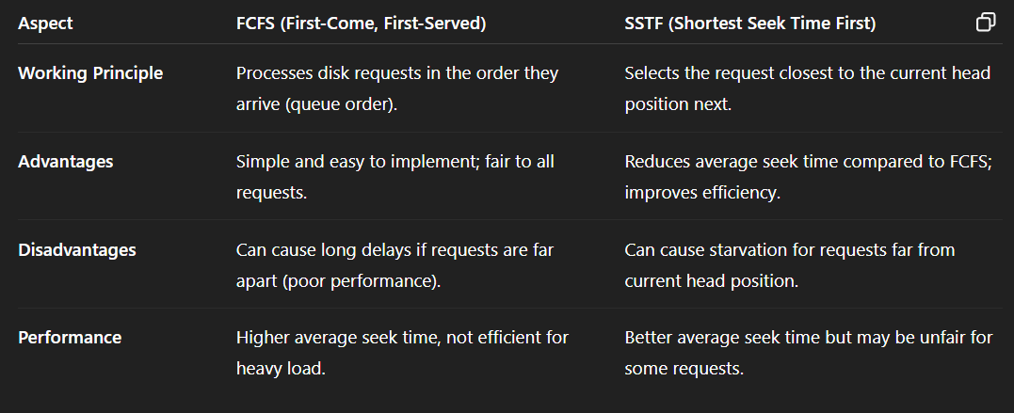

**37 . Compare and contrast the following disk scheduling algorithms: SCAN, and C-SCAN.**

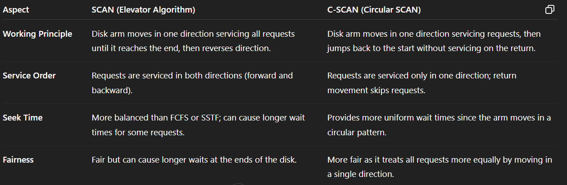

**38. Explain different file allocation methods: contiguous, linked, indexed?**

1. **Contiguous Allocation:**
   * Files are stored in consecutive disk blocks.
   * Easy and fast access since blocks are sequential.
   * **Problem:** Causes external fragmentation and requires knowing file size in advance.
2. **Linked Allocation:**
   * Each file is a linked list of disk blocks; each block points to the next.
   * No fragmentation; file can grow dynamically.
   * **Disadvantage**: Random access is slow because you must follow links from the start.
3. **Indexed Allocation:**
   * Uses an index block that contains pointers to all file blocks.
   * Supports direct access to any block, overcoming linked allocation’s drawback.
   * Extra space needed for index blocks; suitable for large files.

**39 . Justify the concept of sectors, tracks, and cylinders on a disk.**

1. **racks:**
   * A disk platter is divided into concentric circles called **tracks**.
   * Each track is a circular path where data is recorded.
   * Tracks help organize data physically on the disk surface.
2. **Sectors:**
   * Each track is further divided into smaller units called **sectors**.
   * A sector is the smallest addressable unit of storage on a disk (usually 512 bytes or 4 KB).
   * Sectors allow efficient reading and writing of data in fixed-size blocks.
3. **Cylinders:**
   * A **cylinder** is a set of tracks located at the same position on all platters of the disk.
   * It represents all tracks across platters accessible without moving the read/write head vertically.
   * Cylinders reduce seek time by grouping data vertically, improving access speed.

**40 . Describe any three main functions of an Operating System ?**

1. **Process Management:**
   * Manages the creation, scheduling, and termination of processes.
   * Handles process synchronization and communication to ensure efficient CPU usage.
2. **Memory Management:**
   * Controls allocation and deallocation of memory to processes.
   * Keeps track of each memory location to avoid conflicts and optimize usage.
3. **File System Management:**
   * Organizes, stores, retrieves, and manages files on storage devices.
   * Provides access control and maintains file directories.

**41. Describe the services of Operating System.**

1. **Program Execution:**- The OS handles running programs, including loading them into memory, executing, and terminating them safely.
2. **File System Management:**- It manages files on storage devices, providing operations like creation, deletion, reading, and writing.
3. **Device Management:** - Controls and coordinates use of hardware devices (printers, disks, etc.) via device drivers.
4. **Security and Protection:**- Ensures authorized access to system resources and protects data from unauthorized users.

**42. Define OS, User Space and Kernel Space.**

**Operating System (OS):**- A software that acts as an intermediary between computer hardware and users/applications, managing resources and providing common services.

**User Space:**- The memory area where user applications run, isolated from the kernel for safety; user programs have limited access to hardware.

**Kernel Space:**- The protected memory area where the OS kernel executes, with full access to hardware and system resources, managing core functions like process scheduling and device control.

**43. Describe simple structure of operating system.**

1. A simple structure OS is a basic, minimal design where the OS is written as a single program without modular division.
2. **Components:** - It consists mainly of:
   * **Kernel:** Core part managing CPU, memory, and I/O.
   * **System Calls:** Interface for user programs to request OS services.
   * **Basic I/O Functions:** Manage input/output operations.
3. **Characteristics:**
   * Easy to design and implement.
   * Lacks protection and modularity, so less reliable and flexible.
4. **Example:**  
   Early operating systems like MS-DOS follow this simple structure.

**44. Describe monolithic approach of Operating system?**

In the monolithic approach, the entire operating system is written as a single large program running in kernel mode.

**Structure:**- All OS services like process management, memory management, file system, device drivers, and system calls are integrated into one large kernel.

**Advantages:**

* High performance due to direct communication between components.
* Simple to design initially because everything is in one place.

**Disadvantages:**

* Difficult to maintain and debug because of the large code base.
* Poor modularity; a bug in one part can crash the whole system.
* Less flexible to add or remove features.

**45. Describe layered approach of Operating System.**

The **layered approach** structures the operating system as a hierarchy of layers, where each layer is built on top of the lower one, providing services to the layer above and receiving services from the layer below.

**Structure:**  
Typical layers include:

* Hardware (bottom layer)
* Kernel (CPU scheduling, memory management)
* I/O management
* File system
* User interface (top layer)

**Advantages:**

* **Modularity:** Each layer is independent, making the system easier to understand, develop, and debug.
* **Maintainability:** Changes in one layer do not affect others, simplifying updates.

**Disadvantages:**

* **Performance overhead** due to layer-by-layer communication.
* Designing a clean separation between layers can be difficult.

**46. State the different types of operating systems.**

**Batch Operating System:**

* Executes batches of jobs without user interaction.
* Example: Early IBM mainframe systems.

**Time-Sharing Operating System:**

* Allows multiple users to share system resources simultaneously.
* Example: UNIX.

**Real-Time Operating System (RTOS):**

* Provides immediate response to input, used in critical systems.
* Example: VxWorks, QNX.

**Distributed Operating System:**

* Manages a group of independent computers and makes them appear as a single system.
* Example: Amoeba, LOCUS.

**Network Operating System:**

* Supports networking functions like file sharing and communication between computers.
* Example: Windows Server, Novell NetWare.

**Mobile Operating System:**

* Designed for mobile devices with touch interfaces.
* Example: Android, iOS.

**47 . Describe the difference between multiprogramming and multitasking.**

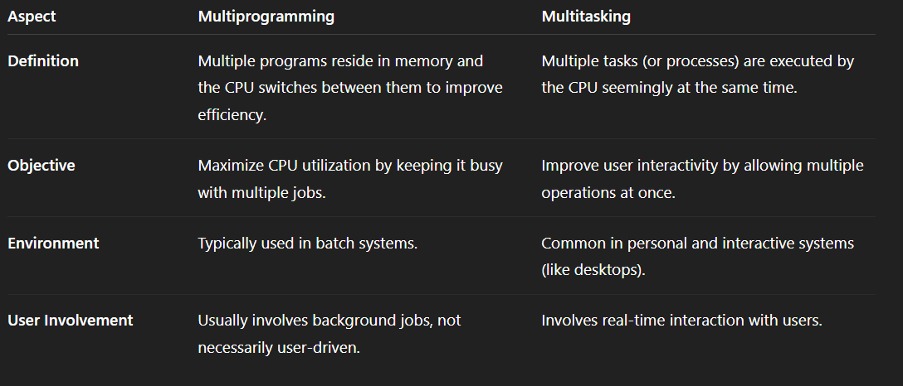

**48. Define Deadlock.**

A **deadlock** is a situation in an operating system where a group of processes become permanently blocked because each process is waiting for a resource that another process in the group is holding.

**Cause:**- It typically occurs in systems with multiple processes and limited resources when processes do not release resources and wait for others.

**Example:**

* Process A holds Resource 1 and waits for Resource 2.
* Process B holds Resource 2 and waits for Resource 1.
* Both are stuck waiting—this is a deadlock.

**Result:**- Deadlock causes the system to freeze or stall, as the involved processes can no longer proceed.

**49 . Explain the necessary conditions for deadlock to occur.**

**Mutual Exclusion:**- At least one resource must be held in a non-sharable mode. Only one process can use the resource at a time.

**Hold and Wait:**- A process holding at least one resource is waiting to acquire additional resources held by other processes.

**No Preemption:**- Resources cannot be forcibly taken from a process holding them; they must be released voluntarily.

**Circular Wait:**- A set of processes are waiting for each other in a circular chain, where each process holds a resource the next one needs.

**50 . Explain mutual exclusion and its role in deadlock formation.**

**Definition of Mutual Exclusion:**- Mutual exclusion is a condition where **only one process** can access a **critical resource** (like a file, printer, or variable) at a time. If another process requests that resource, it must wait until the resource is released.

**Purpose:**- It ensures data consistency and prevents conflicts during concurrent process execution.

**Role in Deadlock Formation:**

* Mutual exclusion is one of the four necessary conditions for deadlock to occur.
* If a resource is held exclusively by one process, other processes needing that resource must wait, leading to a potential deadlock if other conditions (like hold and wait, no preemption, and circular wait) are also met.

**Example:**  
If Process A holds a printer and Process B holds a scanner, and both wait for the other’s resource, mutual exclusion ensures neither can proceed, contributing to a deadlock.

**51. Explain the concept of hold and wait in deadlock scenarios.**

**Definition:**- Hold and Wait is a condition where a process holds at least one resource and is waiting to acquire additional resources that are currently held by other processes.

**How It Leads to Deadlock:**

* When multiple processes hold resources and simultaneously wait for others to release what they need, it creates a **dependency chain**.
* This chain can lead to a **deadlock** if no process releases its held resource.

**Example:**

* Process A holds Resource 1 and waits for Resource 2.
* Process B holds Resource 2 and waits for Resource 1.
* Both processes are **holding and waiting**, causing a deadlock.

**Prevention Strategy:**  
One way to prevent deadlock is to **require all processes to request all required resources at once** (no holding while waiting).

**52. Illustrate Inter-process communication ?**

Inter-Process Communication (IPC) is a mechanism that allows **processes to exchange data and information** with each other, either within the same system or across a network.

**Purpose:** - IPC enables **coordination, data sharing, and synchronization** among processes, which is essential in multitasking environments.

**Methods of IPC:**

* **Shared Memory:** Multiple processes access a common memory area.
* **Message Passing:** Processes communicate by sending and receiving messages through OS-provided channels (e.g., pipes, sockets).

**Example:** Two processes in a chat application:

* + Process A sends a message using a socket.
  + Process B receives the message and displays it.  
    This is IPC via message passing.

**53. Explain the term page fault and its implications in virtual memory systems.**

1. A page fault occurs when a program tries to access a page (a fixed-size block of memory) that is not currently in the main memory (RAM) but is instead stored in secondary storage (usually the hard disk).
2. **Process:**
   * The memory management unit (MMU) detects that the page is missing.
   * The operating system is interrupted and retrieves the page from disk into RAM.
   * The program resumes execution once the page is loaded.
3. **Implications:**
   * **Performance Impact:** Page faults slow down execution due to the time-consuming disk I/O involved.
   * **Page Replacement:** If RAM is full, the OS may need to **replace an existing page** using a page replacement algorithm (e.g., LRU).
   * **Thrashing:** Excessive page faults can lead to **thrashing**, where the system spends more time swapping pages than executing processes.
4. **Example:**  
   If a program accesses an array element stored in a page not in RAM, a page fault occurs, and the OS must load that page from disk.

**54. Illustrate the concept of demand paging and its significance in virtual memory systems.**

**Demand Paging** is a memory management technique in which pages of a process are **loaded into main memory only when they are needed**, i.e., on-demand, rather than all at once at the start of execution.

**How It Works:**

* Initially, none or only a few pages of the process are loaded.
* When the process accesses a page not in memory, a **page fault** occurs.
* The operating system loads the required page from secondary storage (disk) into RAM.

**Significance:**

* **Efficient Memory Use:** Loads only necessary pages, reducing memory waste.
* **Faster Startup Time:** The process can start quickly without loading all pages.
* **Supports Large Programs:** Enables running programs that exceed physical memory size.

**Example:** A program with 10 pages starts executing, but only 3 pages are accessed initially. Demand paging loads only these 3, and others are brought in as needed.

**55 . Explain FIFO page replacement policy with the help of an example.**

FIFO (First-In, First-Out) page replacement is a simple algorithm where the oldest page in memory (the one loaded first) is replaced when a new page needs to be loaded, and the memory is full.

**How It Works:**

* Pages are stored in a queue.
* When a page fault occurs and memory is full, the page at the front (oldest) is removed.
* The new page is added to the rear of the queue.

**Example:** Given page reference string: 1, 2, 3, 4, 1, 2, 5, 1, 2, 3, 4, 5  
Assume 3 frames available.

* Load 1, 2, 3 → Page faults = 3
* Next page 4 replaces 1 (oldest) → Page fault = 4
* Next page 1 replaces 2 → Page fault = 5
* Next page 2 replaces 3 → Page fault = 6
* Next page 5 replaces 4 → Page fault = 7
* Next pages 1, 2 → No faults (already in memory)
* Next page 3 replaces 5 → Page fault = 8
* Next page 4 replaces 1 → Page fault = 9
* Next page 5 replaces 2 → Page fault = 10

56. Define Deadlock along with the four conditions required for deadlock to occur.